London Grip New Poetry – Winter 2020-21
The webzine that thinks it’s a print journal:
(see http://londongrip.co.uk/category/poetry/ for the on-line version)

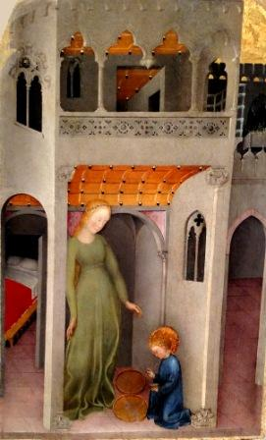

The editors hope you will enjoy this selection of new poems by

*Kathryn de Leon *Steve Black *Chris Hardy *Stuart Handysides
*Briege Duffaud *Frederick Pollack *Ian Heffernan *Brian Docherty
*R.G. Jodah *Maggie Freeman *Elizabeth Smither *Jan-An Saab
*Julia Duke *Jeni Curtis *Jane Simpson *Janet Hatherley
*D A Prince *Devon Miller-Duggan *Bruce Barnes *Jim C Wilson
*Gale Acuff *Merryn Williams *Norbert Hirschhorn *Rodney Wood
*Roger Caldwell *Belinda Cooke *Joan Michelson *John Grey
*DS Maolalai *Antony Johae *Sue Johns *Xan Nichols *Stuart Henson
*Kerrin P Sharpe *John Bartlett *William Doreski *Pamela Job
Copyright of all poems remains with the contributors

London Grip New Poetry appears in March, June, September & December

SUBMISSIONS
Please send up to 3 poems & a brief bio note to poetry@londongrip.co.uk
Poems should be either in the message body or as a single Word attachment
Our submission windows are: December-January, March-April,
June-July and September-October

Editor’s notes

Our cover picture is not, as might be assumed, a Madonna & Child showing Jesus as a toddler rather than a baby. It’s a scene from the life of St Benedict which goes with a poem in this issue by Bruce Barnes. Of course, we do not mean to diminish Christmas; and we do in fact “do God” in varying degrees in poems by Devon Miller-Duggan, Jim C Wilson, Gale Acuff and Kerrin P Sharpe. We also offer a seasonal editorial poem to fit a year when – in spite of all the pressure on HM Government to “bail out” the festive season – most of us will not be following familiar patterns of celebration with our families and friends

Trim the tree

Award a star for good behaviour
then find the fairy who might turn us
into how we’d like to see ourselves
by the reassuring glow
of coloured lights colluding with the dark.
Hang the holly to adorn
the door so sprigs of prickles symbolize
our greetings. Set the mistletoe
to lure someone to kiss and make us royal,
removing spells we’re crouching under.
Meanwhile rummage in the cupboard
for that missing box of decorations.
Count the cards again. Ignore
the nagging feeling something’s been forgotten.

From Tradesman’s Exit, Shoestring Press 2009
Michael Bartholomew-Biggs
London Grip poetry editor
Kathryn de Leon: Prediction 21 June 2020
(after W.S. Merwin)

The world was supposed to end last Sunday
but I completely forgot.
I had planned to check if the sky looked strange
or if the sun dimmed at midday
as it sometimes does
in my dreams.

My mother remembered many such predictions
in her lifetime.
I myself have lost count of those in my life.

Some of us try to push and bend the world
to fit neatly into these prophecies.
Or we push and bend the prophecies
to fit the world.
Especially those of Nostradamus.

Nostradamus.

His huge name thuds
like a black door slamming shut.
How can we not believe?

I hold a bit of my breath
with each prediction
wondering if this could be a correct one.
In 1969 California was to sink into the sea
so I should know better.

But none of this matters
since we will all have our own unique,
personal end of the world.
We are each a sealed envelope
with an indelibly written date,
a life-sized secret, somewhere within us:

the anniversary of our death
that we pass every year without knowing.

On that day, we wake, we eat, we live.
The sky watches us,
patient and filled with God.
Waiting.

Then the day is finished,
forgotten like a turned page.
It rides the earth’s sad blue away from us
but returns again and again
never giving up.

Until finally it stands before us,
its God-sized hands raised
blocking our way
and the world ends
without a prediction

Kathryn de Leon is from Los Angeles, California but has been living in England for ten years. She is a teacher and lived in Japan for six years teaching English to Japanese university students. Her poems have appeared in several magazines in the US including Calliope, Aaduna, and Black Fox, and in the UK, in The Blue Nib,The Cabinet of Heed, morphrog 21, Hypnopomp, Poetry Wivenhoe Poems, and The High Window where she was the Featured American Poet.

Steve Black: Tanka

the inscription in the book
i promised i would read
but never did
something
to remember me by

Steve Black can be found sweeping various streets within spitting distance of London. He has been published every now and then.
Chris Hardy: The Wind Forgets, Always Forgets
George Seferis

We’ve been here
only a few months.
In that time a woman

came to the door
to say
her husband
was dead,

cracked open
at the dinner table.

Also, a man
in the garden
heard his father

was sick,
then was told
he’d died
and quickly left

though the funeral
could never happen.

*

The sun remembers
and returns each day
to the same places.

But the wind,
appearing suddenly
when you turn a corner,

races past,
changing and forgetting
all it touches.

We open windows
to let it renew
our house,

sometimes omit
to close them
before it throws

a vase of flowers aside
on its way
to somewhere else.

Chris Hardy has been published widely in magazines (Rialto, North, Stand, Acumen and many others), and websites (London Grip, ink sweat and tears, One Hand Clapping ..) Some of his poems have won prizes. His fourth collection was the band published by Indigo Dreams. He is in the band LiTTLe MACHiNe which sets famous poems to music and performs them..

Stuart Handysides: Ill wind
after George Mackay Brown – Hamnavoe Market

Like Larkin’s travelling coincidence
the railway carriage filled up
and no one would have spoken
had it not been for Fothergill, who
– after quarrelling with Karen
dumping the insistent Daisy
punching the foreman
and assaulting Perkins whose van
nearly failed to stop on the zebra crossing
because he was answering his phone
to Higglethwaite who demanded to know
where the hell his pie delivery had got to –
walked into the path of the eleven forty-seven.

Stuart Handysides is fast forgetting former lives in general practice and medical editing. His poems have appeared in anthologies as well as London Grip New Poetry, The North, Pennine Platform, Poetry Salzburg Review, Presence, and South magazines, and been shortlisted in several competitions. He has organised the Ware Poets competition for several years.
Briege Duffaud: Widow

That evening in the newly-silent house
I sat among our books and ancient vinyls,
Cohen, Dylan, Viglietti,
Brel and Brassens, Shakespeare, Yeats,
the lives we eavesdropped in our Paris flat,
(Te recuerdo Amanda, la calle mojada …)
before the children and the murdering rows,
before your stubborn love affair
with the glowering countryside,
following that idiot trend
that left our friends, our culture
and our happiness behind.
Mad fool, I cried, come back and tell me now
what bastard of a dream made you betray us!

I can call spirits from the vasty deep.
Yeah right, sneers Harry Hotspur.
And sure enough you didn’t heed my call.

Briege Duffaud is Northern Irish but has spent most of her life in France and England. She worked as a freelance journalist, has published two novels and a collection of short stories. She has been writing poetry for the past two years and has been published in Poetry Ireland Review, French Literary Review, Acumen and Orbis.
Frederick Pollack: Celeb

The fire came within five miles
of the house. It wasn’t her only house,
she had others but was there,
and felt a strange need to “look after” it
till told to evacuate. (Consulting
Ben, she cancelled appearances on
two talk shows.) Black specks settled
on the pool. She stared at them,
uncertain what to do. Other layers
formed on the roof, the decks, the tiles,
but those could be hosed off. (For months
thereafter, she walked around sniffing
the house; perhaps there was a smell
and she would have to sell.) A volunteer
died, she learned from Twitter, stopping
the part of the fire nearest her. After
a week she sent a hand-written note
(Ben composed it) and money
to the family. She never felt
the same about the pool
although still photoed floating in it, legs
extended, drink in its holder, her latest
beside her. A B actor,
he wanted to hold onto her (though Ben
disapproved), and as luck would have it found
a way: his next role
was as a doomed heroic fireman.

Frederick Pollack is author of two book-length narrative poems, The Adventure and Happiness (Story Line Press; the former to be reissued by Red Hen Press), and two collections, A Poverty Of Words (Prolific Press, 2015) and Landscape With Mutant (Smokestack Books, UK, 2018). He has many other poems in print and online journals.

Ian Heffernan: Metaphysical Nocturne
Mario Reviglione

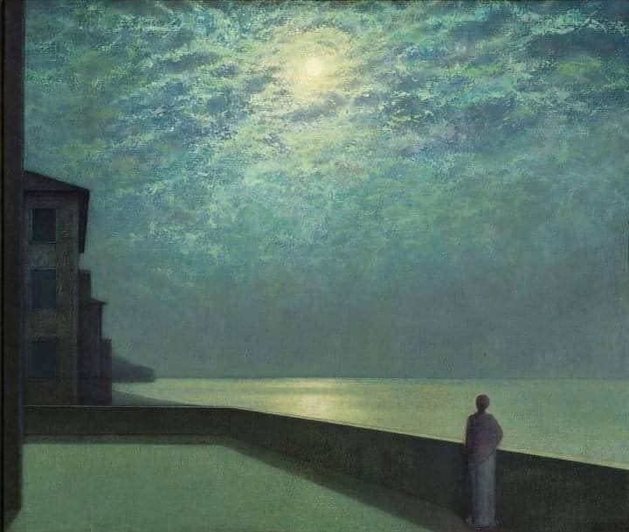
The moon is what we notice first
A bright blurred disc in darkened sky.
We seem to see it through thin ice.
Along the painting’s left-hand side
Blank-windowed buildings stretch away.
Below a plain wide terrace spreads.
Towards its rightmost edge a girl
Looks up, or out across the sea.
I won’t apologise for this:
I mean to pry into her mind.
Her back is turned, but even so
It’s clear to me – I can’t say why –
That what she’s contemplating there
Is not existence but a wound;
A wrong she’s suffered in the past
For which she can’t obtain redress.
The details are opaque, of course –
Abuse in childhood? Talent blocked?
The theft of what she almost loved,
Or what she almost failed to love?
Fatidical, perhaps she sees
The guilty and the innocent
Walk hand in hand and laugh, a life
That closes round oblivion.
Ian Heffernan was born just outside London, where he still lives. He studied at UCL and SOAS and works with the homeless. His poetry has been published recently in The High Window, Ink, Sweat & Tears, Cha, Antiphon, South Bank Poetry, London Grip, Under the Radar, FourXFour, The Moth and elsewhere.

Brian Docherty: Half-Life
(after David Reeve, Abandoned Huts, Dungeness)

Everything here is abandoned, even Dungeness A
Power Station, but the residual energy lives on.

And England’s only desert will live on
while the rest of Kent, Sussex, Suffolk

and who knows what else, crumbles away
and any memories the soil and chalk hold

go to feed the fishes, or amuse the mermaids;
they won’t tell what went on in these huts,

people’s little lives, the pitiful half-life
of human hearts fading away so soon.

What happens on shore stays on shore
might be one way they look at our world

until we venture out to sea, or walk by
their rocks under the new moon, and then

they may take an interest, might even let
the Selkies come ashore in their other guise.

But even they if could, the mermaids would not
come near these huts, they feel the black energy

in their hearts, on their skin, know the big grey
block running its heavy water into their water

could mean the end of everything, an abandoned
world, with no berth for them on the last starship.

Brian Docherty is the Beach Bard of St. Leonards. His new collection, Blue To The Edge, a sequence of memorial poems for his wife, Rosemary, is forthcoming.
R.G. Jodah: Jilted
You can douse those torches, Hymen
and stop your singing. My sister,
your mother, has come to her senses.
The wedding is off.
I'd say it's because of the coffins,
wouldn't you?
All those years of plighting, nephew
(such uncommon fidelity)
and with what does he pitch up today?
Him
who would have us believe
he was cast from that same mould
and by Kresilas himself.
Look at him
standing alone at the altar,
a dower of coffins,
is that a statesman you see,
a leader bestriding this age,
a colossus? Or is he no more
than a dribble of lost wax?
Strategos, my arse.
Nephew, I tell you, if Clio, your mother,
my sister, were blindfolded, left
in a cave on a new moon midnight,
still she would know Archytas
from that son of Acacallis.
Unlike some.
Yes, send the chorus home,
those maggots have stripped the flesh
from that tune, they're just scraping
bone now. Murderers,
the lot of them.
R.G. Jodah lives in London enjoying the silence. His work has recently appeared in: PORT (Dunlin Press), Dawntreader, Ink, Sweat & Tears and The Poetry Kit.

Maggie Freeman: Man in buttercup field: lockdown

He is all angles and sharp lines
drawn across the verticals of the long grass

he has cast his bike down
the handlebars crooked
front wheel twisted at eighty degrees

like his legs which, bent at the knees
to support him where he sits on the ground
make wide-apart vees

points of his elbows propped on his thighs
white tee-shirt, black shorts, forty perhaps
phone clenched to his ear

‘What can I do?’ he is shouting
alone in the field among the blond grass heads
the gold of the tall-stalked buttercups

sweetness of the soft breeze:
‘What the fuck else can I do?’
Maggie Freeman: Opening the shower gel

Sidle my thumb under the plastic lid
and flick, there’s that familiar tautness
across the bones in the back of my hand
which says it’s a modern-life gesture

not one that’s part of the hunter-gatherer
way my body’s evolved, like
walking and running or standing
in the sun under a warm waterfall

in this sunless room water’s falling
on my half-asleep shoulders and I’m pouring
a gold viscous pool in the palm of my hand
transmuting it on my skin to a white froth

redolent of lavender - lavandula angustifolia
I’m awash in the scent of, which reminds me
of the massive lavender
in the huge pot by her front door

and the text she sent late last night to say
her consultant can’t be precise about how long
she’s got - till the end of the summer
maybe, and I’m glad the weather forecast

is promising, and she can sit in her garden
in the sun, which she feels does her bones good.
In a clay pot by my front door
I have planted three little lavenders

Miss Dawnderry, Gorgeous and Ashdown Forest
which grow bushier each day, and send up
long thin stems that sway in the breeze
holding new buds toward the light.

Maggie Freeman has had poems published in The North, Stand and Acumen as well as previously in London Grip. Her three historical novels have recently been republished as ebooks by Lume Books. She lives in East London.
Elizabeth Smither: Warehouse perfume

What is Vanderbilt by Gloria Vanderbilt
doing on this crass display? And
Elizabeth Taylor’s green-glass Gardenia?

The concrete floors, the towering stacks
the tired assistants walking slow
in uniforms of red and black.

Don’t they know, don’t they care
that here are Gloria and Elizabeth
out in glorious limousines and furs

and that they are being thrown out
as if from attics on Fifth Avenue
as cheap as a tip for a bellboy?

Elizabeth Smither’s latest collection of poems, ‘Night Horse’ won the Ockham Book Award for poetry in 2018. A new collection of short stories, ‘The Piano Girls’ will be published in 2021

Jan-An Saab: In Black & White

Beds were made small: never meant for two,

faces were masked to camouflage the truth.

No one brave enough to reveal what is real.

He was convinced, with colours out of sight,

in black & white, relationships would be easy

to control and divorces will not go through.

Affairs would take place as usual for the elite.

He kept repeating, having the right partner,

house and car are a bliss, fewer choices for

us who are not blessed, and only minor effort

required of him, always the chosen one:

who picks holes when he is colour blind?

Jan-An Saab is a trilingual Fine Arts graduate, with 2 children who has worked at Embassies, studying Poetry after work and has pursued further studies in Sciences, pre-requisites for Cranial Osteopathy, since working at a Health Clinic. Her 1st poetry collection is published online and she reads at venues like TheTroubadour and at churches
Julia Duke: Modigliani's Women

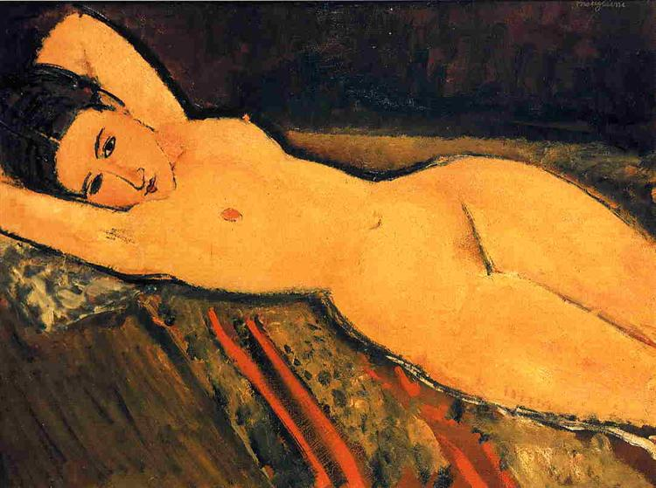
Reclining Nude with Arms Folded Under her Head

They're having no truck with obesity,
no penchant for butties and buns,
shunning burger bars, chocolate, and sugary drinks;
they wear their good habits like nuns.

They pound through the pool before breakfast,
completing their customary lengths,
spend hours at the gym, emerging so trim
that they turn all their weakness to strength.

Admiring each other's sleek outlines,
in leggings and leotards dressed,
they smooth down their minimal bulges
and cover the rest with their vests.

In the long afternoons they spend sitting
with admirable calm and repose
they nibble at fruit and at lettuce
whilst the artist remodels their toes.
Chosen for litheness and vigour,
they take up their arduous pose
and the artist himself, Amadeo,
paints the girl who is wearing a rose.

The hours they put in in the mornings
Once the pains in their muscles abate
Are worth all the strain and the struggle
To the caryatid bearing the weight.

As he sculpts and he smooths and he brushes
his women are coming to light
imbued with the artist's own vision
of what makes a good woman look right.

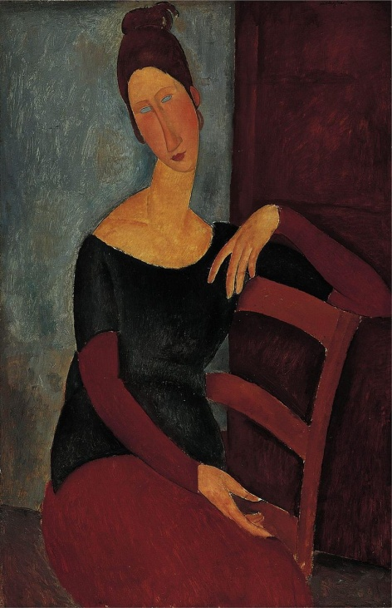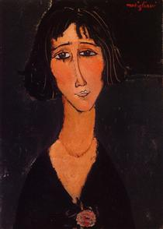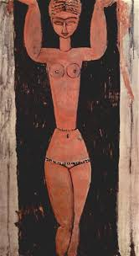
Portrait of the Artist's Wife Young girl wearing a rose Standing Caryatid

Julia Duke is a nature writer and poet who has found her inspiration living in England, Wales and the Netherlands. She has written a regular literary column for the Hague OnLine and published poems in various magazines and anthologies, including Fifth Elephant (Newtown poets anthology) and the Suffolk Poetry Society magazine Twelve Rivers.
Jeni Curtis: postcards to my mother
1
the sun shines in St Petersburg
the scent of lilac wanders
down Nevskyi Prospekt mocks the roar
of Harley Davidsons the cygnets
in Swan Lake are so young
their feathers should be brown
2.
it is green on Kizhi island
you’d love the wild flowers
fields of yellow prove
to be dandelions glory
in humility church bells ring
and men sing a capella
in the summer cathedral gulls
perch on domes
I buy a small horse
3.
what do tourists really see
I see palaces pansies everyday
people churches markets gold
icons lacquered dolls blue sky
blue domes old wooden dachas
rivers lakes locks hydro-electric stations
and trees trees trees
4.
St Basil’s looks as exotic
as in my jigsaw in Red Square,
a book fair I can look
at the pictures but
I can’t read a word

Jeni Curtis is a Christchurch writer who has had short stories and poetry published in various publications including takahē, NZPS anthologies 2014 to 2019, Atlanta Review, Shot Glass Journal, Landfall, The London Grip, and the Poetry NZ Yearbook. Her poem “come autumn” was nominated for the Pushkart prize. She is secretary of the Canterbury Poets Collective, and chair and co-editor of poetry for takahē.

Jane Simpson: Summer sound colour

at the Peacock Fountain
my arm
in a sling
is a concertina
squeezed tight
elbow to hip
six whole weeks

no music escapes
its conjoined chambers
as I sit at the side
watch the jig
all ribbons and bells
maypole and maze
a haze of colour
tap to the fiddle
leading the rail
startle to the clap
of sticks
caught and thrown

look down to where
the pillow was
let air rush in
ease elbow out
let sag
let summer
sing

Jane Simpson is a poet, historian and writer of liturgy based in Christchurch, New Zealand. Her poems have most recently appeared in London Grip, Poetry New Zealand, takahē and Meniscus. She has two collections. Her entry in the NZ Poetry Society’s 2020 International Poetry Competition won third prize. ‘The Farewelling of a Home’, a liturgy, has recently been published in the Australian Journal of Liturgy.
Janet Hatherley: Stroke is what we do to cats

Cross-legged on the carpet
the paramedic sits in front of me

listens to my half-formed answers,
my sentences that tail

into nothing.
Words stumble and stick.

Questions, more questions.
It’s fine, isn’t it, to crave peace?

I turn to my daughter,
will her to answer for me.

Mostly, I’m relieved
we make it to the ambulance in the dark

without the neighbours seeing.
My blood pressure is off the scale,

hits the fairground bell
like a man with a sledgehammer.

The paramedic gives up on the machine,
hand-pumps it the old-fashioned way.

My daughter sees the looks that fleet
between the paramedics.

I settle in their hands,
accept we are going to UCH, the best,

they say, in case anything happens.
They don’t put on the siren.

Perhaps my blood pressure begins to flutter down.
In A&E my hand goes numb.

The scan shows I’m having a stroke,
picks out evidence of others.

My children think I’m dying.
Then it’s over.
They watch me,
fear dementia.

Two days later, the occupational therapist
follows my slow walk along the corridor,

hands me a clipboard at Costas.
If a small hot chocolate is £2.20

how much change from £5?
I cross out answer after answer.

Back home,
fatigue dogs my steps.

I take afternoon naps fully clothed,
count out tablets into compartments.

My brain rewires in slow-time.
I think about getting a cat.

Janet Hatherley is a London teacher with poems published in several magazines, including The Interpreter’s House, Under the Radar, Stand. Commended in Barnet’s Poetry Competition and Indigo Dreams Collection Competition, 2019, she was published in Dempsey & Windle’s anthology, What the moon was told. Work is forthcoming in Brittle Star.

D A Prince: Making the changes

Smiles and goodbyes all round, a kiss and promises
pencilled on the future and fingers crossed!
but then he’s pulled the door near-shut, to show
(she’s out of ear-shot) how he manages
the steps, how the new handrail’s fitted in
exactly - look! - rounded, rubbed down, the oak
angled for her, her height, brick-fast and solid,
two black-lacquered brackets, three bolts each,
matched to the lower step, the broader,
tiles cemented clean, the paving swept of gravel
… one stone, that’s all it takes … - the rail cut short,
precisely, so the car door meets it flush,
no gap, and he can line them up, perfect each time
… that clipped cotoneaster guides the tyres,
so all she has to do … and each week
how her step is shortening, struggles with itself,
but the handrail’s fine, he’d thought about it,
all those hours, nights, knowing there’d be a way
… and her chair goes in the back … a man in the village
with his drill, hardly any dust, right first time
and no trouble, mostly, doesn’t want to fall
… who would?… and how he always gets her there
on time, all those appointments … still what can you do,
no question, being his own answer.

So we admire his handrail, unambiguous,
low sun warming the wood, glints of gold
along the grain, just for this moment
everything all right.

D A Prince lives in Leicestershire and London. Her second full-length collection (Common Ground, HappenStance, 2014) won the East Midlands Book Award 2015. A pamphlet, Bookmarks, also from HappenStance, was published in 2018. She also reviews poetry for London Grip, among other magazines.

Devon Miller-Duggan: Thoughts & Prayers Go Out

That crap about everything happening for a reason:
He was dying because his wife wasn’t praying hard enough—
wildfire infection and some lady from their church told his wife—

I’m supposed to think about how many times per day is enough and pray?
Disease/disaster/friend-whose-mother’s-cousin’s kid has a frightful thing—
That means I remember so-and-so has such-and-such tumor.
Other people’s suffering. I mean, I care. I mean to care. “I care” means?
Means “connection? Crap, I’m so tired of being asked to think about—
so tired of feeling like any being’s survival depends on my,
on my incompetent remembering.

What does it mean about the whole my mind/your body connection
when it’s triangulated with the un-geographical geography of Heaven?
The whole my mind/my body thing is only
some network of nerves or veins they recently found—
what this other thing means, God knows when we’ll know, except we know,
except we don’t.

Thank God it isn’t me? It will be. Or worse.
There’s so much worse that’d break my voice.
But when it’s me, and all your minds scritch-bouncing over my body’s
plaints and threats—

I thought I saw Jesus once, plain—
he wasn’t altogether pleased at being asked for healing while busy
healing. Even a limitlessness gets worn
skin-thin by so many thoughts and prayers, you understand?

Devon Miller-Duggan has published poems in Margie, The Antioch Review, Massachusetts Review, and Spillway. She teaches at the University of Delaware. Her books include Pinning the Bird to the Wall (Tres Chicas Books, 2008), Alphabet Year, (Wipf & Stock, 2017), The Slow Salute, (Lithic Press Chapbook Competition Winner, 2018).

Bruce Barnes: For St Benedict
After the fresco cycle in the Badia Fiorentina

You didn’t do much, as far as miracles go:
shattering a wine glass, retrieving that scythe flung
in a river by a frustrated labourer ,
then repairing your nurse’s sieve, I think –
(that second scene in the fresco cycle
has you praying, as if to get purchase,
while a guidebook secures your handiwork,
for the admiring crowd by the church door )
– but I don’t recognise that flying whatsit
of wood, fixed or patched up, as a sieve.
Where are the holes that make it whole,
where are the handles to hold on to,
while what you must lose slips away?
But you’ll do, as any handyman might,
take the broken sieve in hand, and cuddling it ,
mend and fix its vulnerability to you.
Bruce Barnes is Bradford based, but London born, (within the sound of Bow Bells), and is happy to be of both places. His work has appeared in Northern based magazines such as Pennine Platform, and Strix, and he is a past winner of the Torriano Poetry Competition.

Jim C Wilson: Jakob

He will
not eat thin soup
or buy a shirt that has
wide stripes; he wears long sleeves, against
the chill.

Jim C Wilson: Returning

Lazarus, death-clotted, pale,
and blinking gummed-up clouded eyes,
shuffles out to meet his saviour,
and greet his taken aback relations.

The sun bears down on his wispy scalp.
Does he want some bread, a cup of wine?
He doesn't know; he'll have to think.
The life grows pressing on his mind.

'It's a miracle,' onlookers say,
as swiftly they replan their plans.
And Lazarus stares into their hearts,
draws his shroud close to his body.

Jim C Wison's writing has been widely published for nearly 40 years. Covid-19 brought to a halt the Poetry in Practice classes he ran since 1994. His most recent poetry collection is Come Close and Listen (Greenwich Exchange). More information

Gale Acuff: Beans

When I die I guess I'll know it I say
to my Sunday School teacher but what good
will it do me then and she answers Well,
Gale, leave that for God to reveal to you
so I say Yes ma'am but think she's full of
beans, nobody knows what's on the other
side and maybe not even those who live
there and that's where everybody's headed
sooner or later, I'm ten years old so
later works for me and my teacher's old,
25, so I tell her (and I choke
on my words just like in my comic books, when
folks aren't gasping) and say I'll miss you, ma'am,
when you're gone and she says Yes, so will I.

Gale Acuff: Relativity

I guess I won't mind being dead, not that
I can do anything about it save
try to wind up in Heaven and not Hell
is what I told my Sunday School teacher,
who started to cry and then reached for me
but I pulled away and then she fell a
-cross the desk so I reached for her to raise
her up but she took both my hands so that
means that she reached me after, touched me
after I reached for her and I think that's
the kind of miracle we ought to read
in the Bible, it makes a lot more sense
than parting the Red Sea though not as much
as saving that woman from being stoned.

Gale Acuff has had poetry published in Ascent, Reed, Poet Lore, Chiron Review, Cardiff Review,Poem,Adirondackeview,Florida Review, Slant, Nebo, Arkansas Review, South Dakota Review, Roanoke Review, and many other journals in eleven countries. He has authored three books of poetry: Buffalo Nickel, The Weight of the World, and The Story of My Lives.
Merryn Williams: Antarctica

The penguins thought no harm. They toddled up,
and clucked, and gazed at these strange bearded men.
The strangers were amused.
But it was necessary to kill the penguins.

This woman thought no harm.
She gladly let him come too close, but he
had wider aims, his core was cold. He swung
his axe. He left her bleeding on the ice.

Merryn Williams lives in Oxford. The Fragile Bridge: New and Selected Poems was published by Shoestring Press in 2019.

Norbert Hirschhorn: A Disquisition On Time
(With help from Stephen Hawking)

‘Time’ is only what a clock reads: your wristwatch, the steady oscillations of a caesium molecule (nine billion times equals one second). Tick tock tick.

Einstein joked that Time is what keeps two bodies from occupying the exact same space at once. No joke: Even when I’m inside you, we’re still separate.

The faster I move, the slower my clock, so I’d better keep moving to stay young. The higher I go, the faster my clock, so I’d better keep my head down.

Time slows near a substantial body: as when I’m within your orbit, my dearest.

Time’s arrow flies forward as disorder rises (‘entropy’). My decay is what I endure as Time.

Or, Time is just one lonely day after another.

Norbert Hirschhorn is a public health physician, commended by President Bill Clinton as an “American Health Hero,” and proud to follow in the tradition of physician-poets. He lives in Minneapolis, Minnesota. He has published six collections, the most recent a bilingual Arabic-English co-translation with Syrian physician-poet Fouad M. Fouad of the latter’s poems, Once Upon a Time in Aleppo (Hippocrates Press). See his website, www.bertzpoet.com

.

Rodney Wood: Holding A River In My Head
“And plagues drive people crazy. You might call them mass-disinhibiting events.”
Andrew Sullivan (A Plague Is an Apocalypse but It Can Bring a New World,
New York Magazine 21/7/20).

Wednesday. There’s nothing in the diary.
No letter or emoji, no location or time,
for a Zoom video conference.

Today there’s only this house
& this garden where faeries live.
I find myself worried that birds

have not been eating the suet balls
I left out for them in a feeder.
Maybe I need to move it from the lawn.

Trousers hang from the washing line.
Already my mind’s buzzing
with questions but it’s not yet lunchtime:

1) are my trousers dry yet?
2) who moved the bird feeder?
3) who’s stolen the mower?

I don’t mean to but I think violently.
My body is inflamed
& sweat runs off me like a tide leaving the shore.

Arteries are branches that are muddy & soft.
Something's not right here
as my skin opens without a puncture.

I want to be a fish, no something else
that can at least dial 111
& talk to God in the language of silence.

Rodney Wood worked in London and Guildford before retiring. His poems have appeared recently in Atrium, The High Window, The Journal, Orbis, Magma (where he was Selected Poet in the deaf issue) and Envoi. He jointly runs a monthly open mic at Write Out Loud Woking. His debut pamphlet, Dante Called You Beatrice , appeared in 2017. You can find more information about Rodney and his work at rodneywoodpoet.wordpress.com

Roger Caldwell: Yellow Bird

Yesterday I saw a yellow bird
hang upside down
from a small white cloud –
I guessed that it was trying
to tell me something.

Yesterday came other signs too.
I heard a voice speak from a tree
though what it said –
the words were indistinct –
was lost in rustling of leaves.

The sun shone with a strange new light,
and when I raised my eyes to it
a giant yellow eye stared back.

Yesterday so many marvels,
portents of great things to come –
I lay half-awake all night,
thinking about them.

And yet today the sky is dark,
rain hour by hour
patters down on dustbin-lids,
and sodden yellow feathers everywhere
clog up the overflowing gutters.

Roger Caldwell’s latest poetry collection is Smoking Opium in Moscow (Shoestring Press 2020). He also writes on philosophy and is a regular contributor to Philosophy Now.

Belinda Cooke: Translations from Marina Tsvetaeva’s After Russia

Clouds

1.

All ploughed up --
these battling explosive skies,
these skies paved out
with battles...

Migrations of herds,
horses whipped up by
the lash, beneath the
shining widowed moon,

2.

But isn’t that Phaedra’s
shawl beneath the sky? Phaedra
soaring up in this marathon
flight of the racing heavens?

Or even Herodias, grasping
a forelock, while a tambourine,
soars into these racing heavens
to the sounds of Jericho’s trumpet.

3

No, the great wave rises and
falls -- the prophet speaks true:
a parting of the waves
as seas divide in two,

a procession of beards
and manes along the Red sea?
No, all wrong -- it is Judith
holding up the head of Holofernes.

Words and Meanings

You don’t think about me ever,
unless as some clingy woman!
You think about me as little as
wires stretching out in the distance.

You don’t complain of me, that it’s a pity...
sweeter than everyone, they say
but think of me at least as
a pedal, a pedal prolonging the pain....

2.

Palm to palm.
Why were we born?
Please don’t pity me:
No it’s just to drag out the pain...

Distance protracted by wires....
Distance and pain, the same palm
keeping itself apart for how long?
Distance and pain are one and the same.

Marina Tsvetaeva (1892-1941) is now considered one of the greatest twentieth century Russian poets. She lived through and wrote of the Russian Revolution and the Moscow famine that followed. She left Russia in 1922 living in increasing poverty In Berlin, Prague and Paris, before returning to Moscow in 1939. Her husband Sergei Efron and her daughter Ariadna were arrested on espionage charges in 1941. Efron was executed. and Alya imprisoned. Desperately isolated in the new Soviet regimeand in extreme depression, Tsvetaeva committed suicide in 1941 survived only by her son, who died in a penal battalion shortly after.

Belinda Cooke’s most recent translations are Kulager by Ilias Jansugurov (Kazakh National Translation Agency, 2018); Forms of Exile: Selected Poems of Marina Tsvetaeva (The High Window Press, 2019); (et al) Contemporary Kazakh Poetry (Cambridge Univ. Press, 2019). Her own poetry reflects her Irish background, while exploring ambiguities within relationships as in Stem (the High Window Press, 2019) and her forthcoming Days of the Shorthanded Shovelists from Salmon Poetry.

Joan Michelson: Wirewalker

At dawn he lifts his balance pole, takes
a step to test the wire strung in secret,
and starts to cross between the Twin Towers.

A bird with strange red eyes flies close
above his head and circles. Uncertain,
the acrobat continues. As he planned,

he crosses eight times between the Towers,
pausing once take a rest. He sits astride,
his legs stretched out, then lies face up

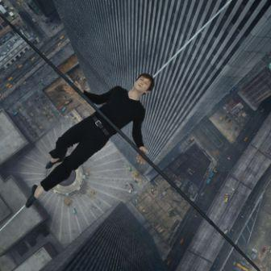

along the length and sees the bird that’s hovering
close. It’s not an eagle like the bird
who fed daily on the liver of Prometheus.

And the wire walker is not a demi-god.
But it makes him pause to think about his hubris
and he wonders if he’s over-stepped the human.

But he feels protected by the Towers
as if they’re high air creatures and his brothers;
and the bird too could be a brother. His passage

between the Towers might be a trespass and lead
to his arrest but for here and now, his home
is the high air. He lingers before continuing,

stops only when the police are threatening
to lift him off. He stops and bows. He bows
four ways, up to the Twin Towers, North and South,

to the bird and to helicopter that’s come too close;
right, and left, and down to the crowd that’s watching.
As if he’s understood, the red-eyed bird circles

one last time and flies up, up. Years later
the wirewalker will see the Twin Towers fall.
He will feel them die; and he will mourn.

But when the news breaks and repeating TV
footage shows the ending, although in Paris,
he’s right there with the office workers

stepping out from the high tower windows.
Reaching out he takes their hands
so they can fly together into higher air.

Joan Michelson's recent publication include The Family Kitchen; 2018, The Finishing Line Press, KY, USA, Landing Stage, 2017, SPM Sentinel Books, UK and Bloomvale Home, 2016, Original Plus chapbooks, UK

John Grey: That Sniper

That's him up at the third floor window of the old abandoned
piano factory building.
He's armed with an automatic weapon and is firing shot after shot
at the street below.
But no one's out walking because nobody lives here.
He can spray the sidewalk all he wants but all he'll hit are
cracked cement or weeds.
Shells bounce off the ruptured tar like popping corn.
Can't break windows of the stores because they're already smashed.
And what's the fun in hitting the targets of the dilapidated Roxy.
There hasn't been a movie there since Dirty Harry was at the Police Academy.
He may as well fire into the air but don't expect to hit a bird.
Or turn the damn thing on himself.
He can blast away at nothing, a target all his own.

John Grey is an Australian poet, US resident, recently published in Soundings East, Dalhousie Review and Connecticut River Review. Latest book, Leaves On Pages is available through Amazon.
D S Maolalai: The mime

we were staying
at his house. this was
Croatia. 2015. and during the war,
he told us,
he had been a sergeant
and a captain then
afterward; now
he made our beds
while we visited museums
and the beach. that night

his wife cooked stew
which his daughter served in red bowls,
and he got maudlin
drunk on spirits,
showed us his helmet,
showed us his gun.
and he showed us medals,
and a knife
he had taken from someone's body,
and pictures of his friends – “dead”.

his English was not
very good and he told us
that for a while
he'd been a sniper. said
it had been
very difficult, miming
through splintered language
an explanation;

the eyes, yes – because you had to see
so often
men’s eyes.

DS Maolalai has been nominated seven times for Best of the Net and three times for the Pushcart Prize. His poetry has been released in two collections, Love is Breaking Plates in the Garden (Encircle Press, 2016) and Sad Havoc Among the Birds (Turas Press, 2019)

Antony Johae: Poppies

The pinned poppy has a centre like a black hole; it sucks soldiers in.
The rest is red, redolent of blood, risk, cross, flame, passion,
men cut down, blown up, caught in Helmand’s traps, snipers’ sights,
boxed, brought back, and buried in Britannia’s dark November.
The pinned poppy pricks a finger, startles the wearer into issues,
inquiry, the wherewithal of war, its spur and whereafters.
The reason’s not in heroes – service, sacrifice, duty, country, God,
but in the pod: Papaver fields on Afghanistan’s rich hills,
heroin harvest, cartel-trafficked, sinews of war, purchase of arms:
field piece, mortar, missile; munition, mine, timer,
war’s panoply, forged from God’s plant.

Monet painted them flaming away into a far field
a woman picking one in the drowsy afternoon.
In Flanders too they grew in soil touched by war
bodies bloodied, splayed in death
gas gasp, mask, last rasp, limbs lost, rotting,
rats, ditch run red, men retched in throe,
wounded to tents, agony – from poppy – opium-appeased,
relief, amputation, release or – after armistice –
day addiction, dread dreams: stained in stench,
trench, drenched – bullet, bursts, barbed wire,
discharge, detonation, flash, flesh, death . . .
‘Nurse! Sister! Love! Wife! My medicine!’

Covid-19 allowing, Antony Johae divides his time between Lebanon and the UK. He came out with Poems of the East (Gipping Press); in 2019, After-Images: Homage to Éric Rohmer (Poetry Salzburg); and in 2020, Ex-Changes (The High Window). “Poppies” comes from Home Poems (in progress).
Sue Johns: Winning

They should wash their mouths out with soap and water, your leaders, stepping onto podiums, recommending distance, vodka, disinfectant. Their lecterns are rolled out to support the economy. You must wrap your team scarves tight around your mouths, go into the stands, remove the poor and aged identifying your favourite players from the numbers on their body bags. To hell with Wimbledon, cricket, The Olympics, there is only one game the world is watching, the rules are mine and they are unpredictable. Before each match you foolishly touch and retouch your faces to soothe, de-stress. You would be better off sitting down and colouring me in with your children – deathly red, mysterious violet, a soft and hopeful green. I am an invisible athlete, a simple grey at best. So much running, running, running, people who have never run in their lives are running for their lives, in circles – go home applaud from your windows. Nothing is winning in the Wet Market, the cages hold no hierarchy, fear is a strangled anthem as the dogs hang glistening like medals. Hand, wing, claw I pass like a baton. Nature is still under the knife as you struggle for breath. When you are allowed out to play you won’t remember how to, you’ll pick and dig at anything that will draw blood: scabbed knees, old sport injuries, the graves of relatives. By then I will be holed-up with something soft, helping to lick its wounds and resting before we map out the training for the winter season.

Sue Johns originates from Cornwall where she started performing as a punk poet. She has published two pamphlets and two full collections, the most recent Hush (Morgan’s Eye Press 2011) and Rented, Poems on Prostitution and Dependency (Palewell Press, 2018). She is studying for an MA in Writing Poetry.
Xan Nichols: Mediterranean
(after Gabriel Levin after Rimbaud)

There’s a space shyly hidden among
rocks where the tamed sun gathers its strength.
A stream lingers, at last, on the sand.
It’s a pool of warmth beneath cold cliffs.

A young man, calm, all muscles loose,
floats just beyond the surf’s easy break,
rocked by the homing waves. His submerged
hands are pale and altered by water.

He’s thrown his head back, eyes closed, to feel
the sun on his vulnerable throat.
The waves hush him, running up the beach.

There’s the big silence of abandoned
places. He doesn’t move. Behind him
a little flotilla of life jackets.

Xan Nichols was born and raised in the Republic of Ireland of Scottish parents. He taught English in Europe and Asia and currently works as a teaching assistant in an English Comprehensive school. He believes passionately in political and social engagement, in attempts to understand, without anger or hatred
.
Stuart Henson: 2020

Bad year—so many ways.
Deceit. Confusion. Tolling death.
Yet much grown gold: the hedges
quick, fat haws, matt sloes,
gatekeepers, midges, fruit in swarms.
The house is steeped and cidery—
Blenheim and Bramley burnishing.
Things spoil; things shine;
sly months file on… You’d need
good eyes to see it through, good luck,
and some philosophy at home with doubt.
Big ask, that capability. Burden enough.

a Post Card to, a collaboration between Stuart Henson and John Greening is published this month by Red Squirrel Press. stuarthenson.co.uk

Kerrin P Sharpe: the ways of rain

the open grave of the window cleaner
his coffin apple-bobbing the sides
his wreath of roses their polystyrene boat
the mourners unsure whether to look or leave
the Priest He leads me beside the still waters
the mourners unsure whether to smile
the mourners remembering the words
of the window cleaner I’ve one eye
against the sky the window cleaner forgiven
for taking the ways of rain in vain
forgiven for all those dirty dinners
he fed the sea the ways of rain deep
deep as a Saviour’s love giving
the window cleaner a way to row home

Kerrin P Sharpe has published four collections of poetry (all with Victoria University Press). Kerrin has also had her poems published in a wide range of journals both in New Zealand and overseas including Oxford Poets 13 (Carcanet Press UK) and Poetry (USA).
John Bartlett: Go Firmly
after The God Abandons Antony by C. P. Cavafy

your funeral was not meant to be
an entertainment
when I saw your coffin live-streaming
down the aisle
I wanted to change the channel
I wanted to change what you’d meant
to me
of course there are tears for
what is lost
but why weep for what has never been ?
-that’s merely petulance
there were letters left forgotten
-calls unanswered
our lives barely nudging against each other
then moving on
after the service I walked on the beach
seaweed towered above me like
uninhabitable high-rise
and I was small again
so go now firmly to the window
and weep your paltry tears
of farewell

John Bartlett is the author of three novels, short stories, non-fiction and three poetry collections. He was the winner of the 2020 Ada Cambridge Poetry Prize and lives on the southern coast of Australia. beyondtheestuary.com

William Doreski: Dark Passage

Toting a trapped mouse to the woods
at night, my headlamp burning.
When I open the trap the mouse
strolls out, pauses to paw smears
of peanut butter from its chops,
then strolls leisurely away.

The night is rolling big cigars
and smoking them fiendishly.
Stars pop like pimples. Gases
form nebulae larger than all
the life that has ever pulsated.

One fat little field mouse
embodies this energy as well
as the force of gravity does.
I’m glad I didn’t kill it,
although its gritty life suggests
a casual lack of conscience.

The fan-shaped light I cast
as I walk back to the house
slashes through a deadweight of dark
that otherwise would oppress
and cause me to lose my bearings.

The ground underfoot retains
its illusion of solidity, but
trees have vaporized, leaving
only scars and stains on a wall.
I can’t imagine a bat sailing
through this cast-iron dimension.

When I step into the breezeway,
a fully lit space, I snuff
the headlamp and become human
again, the hole I drilled in the dark
quickly healing behind me.

William Doreski has published three critical studies and several collections of poetry. His work has appeared in many print and online journals. He has taught at Emerson College, Goddard College, Boston University, and Keene State College. His most recent book is Stirring the Soup. williamdoreski.blogspot.com

Pamela Job: A Walk Through Time

A short way along the track into the hills
and I have taken on chequered shade
like a new skin. Sun dazzles me through
branches, wind tears leaves from them,
part of the inevitable seasonal roughness here.

I glance down at my hand, its dappling tells me
I am on my way to becoming translucent.
Soon I will see the cogs and springs, all the workings
inside the case of me. To my left, a red squirrel skips
around in the walnut tree, a nut in its mouth.

I hear a rhythmic sawing, the shell cracks
as it gnaws a way in, fluffed tail erect behind
tufted ears. Sun-struck, it sits in fractured light.
It watches me watching it, chatters to itself, up
it skitters into foliage, teeth clamping another nut..

I feel I have moved beyond skin into another
dimension, and, as I write this years later,
I’m there again, in that dappled afternoon;
a living thing untamed, free, and me, close
as kin, and both, on that day, unafraid.

This year Pam Job was awarded a Fourth Prize in the Kent and Sussex Poetry Competition, was Commended in the Charroux Literary Festival Poetry Competition, has been published in Poetry in the Plague Year ( The Poetry Kit), and in Carl Griffin’s collaborative book length poem, Arrival at Elsewhere (Against the Grain), 80% of sales of which go to NHS Charities Together.

