London Grip New Poetry – Summer 2015
(The website that thinks it’s a print magazine)

This issue of London Grip New Poetry can be found on-line at http://londongrip.co.uk/category/poetry/ and features new poems by:
*Stephen Bone *Anthony Costello * Edward Mycue *Ben Banyard
*Derek Adams *Danielle Hope *Imogen Forster *Pam Job
*Ajise Vincent *Peter Phillips *James W Wood *Antony Johae
*Norbert Hirschhorn *Genevieve Scanlan *Tanya Nghtingale
*Kat Soini *Katherine Venn *Jan Hutchison *Peter Branson
* Teoti Jardine * Ian C Smith * Jeni Curtis * Maggie Butt
* Ian Humphreys * Myra Schneider

Copyright of all poems remains with the contributors

London Grip New Poetry appears in March, June, September & December.

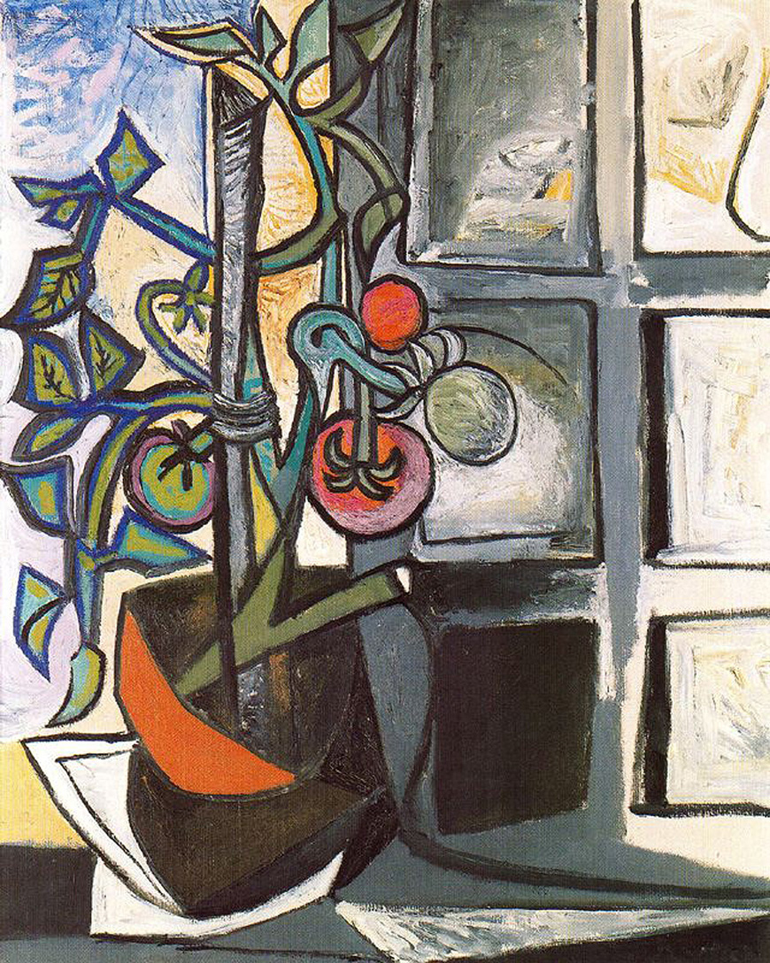

Please send submissions to poetry@londongrip.co.uk,
enclosing no more than three poems (in the message body
or as a single attachment) and a brief, 2-3 line, biography
Editor’s introduction

This summer edition of London Grip New Poetry is the first one to celebrate itself with a launch reading. Enfield Poets have been generous enough to invite us to perform on June 6th at their welcoming venue in the Dugdale Centre. London Grip will be (future tense is still appropriate at the time of publication) represented by Derek Adams, Stephen Bone, Maggie Butt and Katherine Venn, all of whom appear in this current LGNP posting (and also in previous issues). A unique selling point in this event is that each of our featured readers has been asked to choose and perform a couple of poems by one of the excellent overseas poets published in LGNP during the last four years. I am very pleased that we have been able to present to English audiences some fine poets from Africa, Asia, Australia, Canada, New Zealand and the United States. And of course the on-line international nature of London Grip means that we have also been introducing Australian poets to Canadian readers, Asian poets to North American ones and English poets to audiences everywhere!

We hope this summer launch reading will not be a one-off event and would welcome invitations from other poetry venues for future issues.

it is probable that many of our readers will identify our cover image as the tomato plant painting referred to in the poem 'Picasso's Studio' by Derek Adams.

Michael Bartholomew-Biggs http://mikeb-b.blogspot.com/
Stephen Bone: Boyhood Of Senesino

Tremulous as a pot-bound hare –
never before so close to wealth and title –

I poured into pomade-scented air
the gift God had graced me.

Pierced the spangled matrons' granite hearts,
drew from grown men a drip

of tears with songs of ache and loss;
then with a seamless switch slipped

into laughing coloratura, skylark notes
that threatened the Murano bowls,

panels of quicksilvered glass. Even my father,
face a map of hardship, swagged a smile,

weight of a heavy purse already in his hand,
eyes glinting like polished knives.



Senesino (1686-1758 ) was a celebrated Italian castrato
Stephen Bone: Not out of the woods yet

Left with this, I watch
the scribble of your heart

its flashed beat
and I will you

to hack through branches
dense undergrowth

to reach open ground,
green and shadowless.

Stephen Bone's work has appeared in various journals in the U.K. and U.S. including And Other Poems, Hinterland, London Grip, Seam, Shotglass, Smiths knoll, Snakeskin,The Interpreter's House, The lake and The Rialto. Most recently in Ink,Sweat&Tears and Clear Poetry. First collection In The Cinema,published by Playdead Press 2014.

Anthony Costello: Rapture

How the word can snatch away
like a bird of prey; say it quickly
and eagles & hawks appear,
the owl in flight, a hollow call,
the dread of something feathered
in the woods with your face on it –
bliss, a rare bird calling from afar.

Anthony Costello's first collection of poems, The Mask, was published in October, 2014 by Lapwing Publications, Belfast.
Edward Mycue: Necessary Conditions

Many of us could never go home
even when we had not left it.

Home is a windsong in our hearts.

These hearts have exploded,
repositioned themselves, ending
as much the mends themselves
as the remaindered hearts.

The heart needs permission to come home

where contrition’s not expected,
and explanation is enough.

Edward Mycue has lived in San Francisco, CA since 1970. He was born 1937 in Niagara Falls, raised in Dallas from age 11 with school there and Boston. His first book was Damage Within The Community. In 1979 came The Singing Man My Father Gave Me from Anthony Rudolf's Menard Press in London. Mindwalking, selected poems, came out in 2008 and Song Of San Francisco in 2012.
Ben Banyard: Darkroom

After she died, he tried it for size;
not much more than a coal hole, a cramped cell,
yet here he’d documented the family.

He took a fresh brew to the lounge
with his books of negatives and contact sheets
and peered at the images with a magnifying glass.

Here his son’s eleventh birthday,
his daughter, small and serious in a tutu
and there his wife, a tiny smiling profile.

There were dozens of pictures he hadn’t printed
and later, bathed in red light, he held his breath
as he rocked her face back into life.

Ben Banyard lives in Portishead, where he writes poetry and short fiction. His work has appeared in print and online in Popshot Magazine, Lunar Poetry, Sarasvati, Ink Sweat & Tears, Snakeskin, The Stare's Nest and others. Ben edits Clear Poetry, a blog publishing accessible contemporary poetry every Monday and Thursday
Derek Adams: December Morn, 1915
after a photograph by Theodore Miller

The snow is not deep
but my sneakers are thin,
toes already numb.

Papa’s camera is prepared,
stood on three wooden legs
that do not shake like mine.

White arms close to my side,
hands balled into fists,
teeth gritted to stop them chattering.

‘Keep still Li-Li
and do not smile.’
I do not smile.

I think about going indoors:
putting all my clothes back on,
the hot chocolate Papa has promised.

He inserts a glass plate in the camera.
Uncovers, counts two, then covers the lens,
says ‘I will call this one December Morn.’

Derek Adams: Picasso’s Studio
‘Picasso and I fell into each others’ arms and between laughter and tears and having my bottom pinched and my hair mussed we exchanged news…’ Lee Miller. Vogue October 1944

He takes my hand, pulls me
into the studio. Shows me
the this and the that of it.

A portrait of Nusch Eluard on a scrap
torn from a paper tablecloth,
coloured with fruit and vegetable juice.

Eight canvases, some still wet,
of the tomato plant on the windowsill
his new favourite model.

I pick one of its small soft ripe fruits
pop it in my mouth. Picasso scowls.
I explain, ‘I love the idea of eating art.’

Derek Adams is a professional photographer who writes poetry because he has to! He has published 3 collections of poetry; the most recent unconcerned, but not indifferent is a poetry portrait of the surrealist artist Man Ray. He has an M.A. in creative and life writing from Goldsmiths.
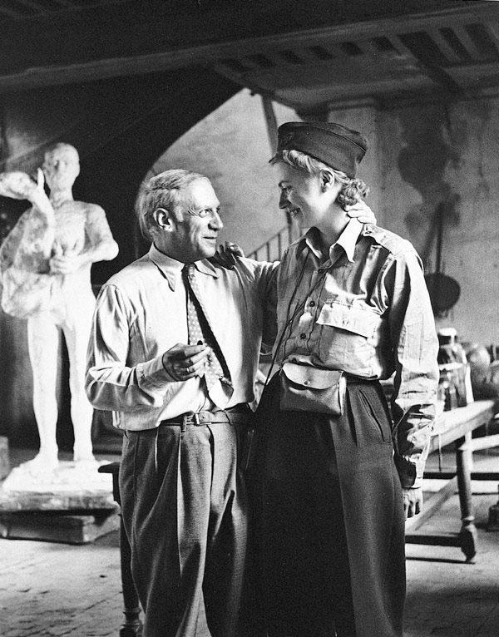

Danielle Hope: Sower
1888 Van Gogh

Extinct now, this man
that under the dinner-plate sun
scatters grain from his right hand.

Rising from a purple sea of furrows
he is the blackness of a lone tree
branches barely dawning in yellow buds.

If the crows will eat elsewhere
as daylight lengthens
he can watch his gems grow.

Others now ride the new sowers –
bright red machines toil the hours –
gold grains carted in trucks and ships.

Gone is his muscled finger and hunched back,
his head bent to blue earth, cap pulled down,
left hand clasping tightly.

Danielle Hope is a poet and doctor, originally from Lancashire, now living in London. She founded and edited Zenos, a British and international poetry magazine, worked for Survivors’ poetry, and is currently advisory editor for Acumen Literary Magazine. Her work has been published widely in magazines, anthologies and on the London Underground. She has published 4 collections with Rockingham press. Website www.daniellehope.org
Imogen Forster: Storks on a roof, Figueres

Four storks – three white, one black –
on an ordinary high, flat roof.

White, with his black wings, is not purely white,
while Black is all black but for his white belly
and his scarlet bill and legs. These are
two birds from a manuscript’s margins,
an illuminator’s idle sketch.

They stand as if carved in oak,
heraldic birds set like watchmen
at the ends of a pew or the tall,
finger-weathered pieces
of a giant’s board game.

Back to back, face to face,
formal and comical,
and as utterly still as the
knot of people who stand
gazing up at them.

Imogen Forster is a translator, mainly of art history, and publishes poems on-line and in print. She posts haiku on Twitter as @ForsterImogen.

Pam Job: Highwire Act
Now the funambulists are back in town
bringing their golden birds and rainbow
kites to fly like thunderclouds over the heads
of the crowd. Air is their world
and they will show us how to navigate
uncertainties, how to juggle our lives
between sparkle and sequins, between
the light of the moon and the spotlights.
They will demonstrate balance as an attitude
while spanning the griefs that divide us.
Remember, we are looking for ourselves,
for our reflections in mirrors held up by the clowns.
Pam Job: Me and Kim Jong Un
Bring your notes, my writing buddies said.
It’s always good to see your work in process.
I read at random: Bacon shows the self for what it is.
Then: Subway in New York is more diaristic
because of the pressure of time. I look gnomic,
carry on: A quiet creeps into your work of still looking
but her time and the rhythm is more lulling.
It did seem important that Camille Pissarro was born
in the Caribbean and that Elizabeth Bishop was preoccupied
with figuring maps of places we inhabit.
Bits of my mind fluttering away, chattering
to themselves and me, trying now to net them.
How about: the symbolic act – there was no Gulf War.
I could try to re-write history as poetry, deny it all,
right back to Eden. Somehow that seems a dishonesty.
Then I think of Kim Jong Un, surrounded by his men
taking notes of every word he says. They'll end up with stuff
like mine, nonsense strewn on every page,
but they are paid to turn it into song.

Pam Job has won awards in several poetry competitions and has co-edited four anthologies, most recently KJV: Old Text - New Poetry (2011) for the 400th anniversary of the publication of the KIng James Version of the Bible and so too have the doves gone (2014), reflections on the theme of conflict to commemorate the centenary of WW1. Her poems have been published in Acumen, The French Literary Review, Artemis and From the Saltings to the CIty, an anthology of Essex poems. She helps organise Poetry Wivenhoe, a live monthly poetry event in Essex.
Ajise Vincent: The Elders

The elders of my land
aren't groomers of dreams
neither are they waterers of visions
they are termites who feast on seeds
meant to feed posterity.

The elders of my land
are not wise men with grey hair
whose grandeur seeks peace at the birth of dawn
and solitude at the demise of dusk
they are mediocrities who propagate diatribes
to boost their fame.

The elders of my land
are not seers who make forecasts
neither are they prophets of truth
they are pharisees of doom
who deserve to go blind
on their way to Damascus.

Ajise Vincent is an undergraduate of Economics at a prestigious University in Nigeria. He is a contributor to various online and print magazines.

Peter Phillips: Ukraine Sunflower

Dogs were howling. I don’t know what breed
but something like wolves; so maybe Alsatians.
They wouldn’t stop, their noise was contagious.
Soon, we were all weeping. When they came,

we quietened, but not the dogs. Soldiers
picked through our debris-scorched field. Most
wore balaclavas. Only yesterday, children had skipped
through us, laughing at how tall we were. We don’t

feel tall now. Soon trucks arrived,
more soldiers. The dead were found, their pockets
emptied. Dogs kept howling. Pieces of the plane
were scattered, some crushed us. I said,
Can we still be called Sunflowers?

And the dogs? They were shot.

Peter Phillips' fifth collection was Oscar and I, confessions of a minor poet (Ward Wood Publishing, 2013). He is currently writing a series of poems called Saying it with Flowers.
James W Wood: Gush

A dry season
and the dust
settles hard on the riverbed:
no water for miles. Atmospheres
thicken with the tang of rain,
clouds boil, skies blur into slate, a breeze
keens through the hills, the klaxon
of a deluge coming. And though longed for, it frightens:
livestock disappear, men
take cover in shacks, huddling
for protection. Drop, drop,
the fat
and fatter, the hiss and stream
from trickle to torment, the gloop and splatter
of water on glass. Mud
rages through the gulch, branches drown
and the river thickens as its tributaries
thunder into chorus. This year
will be good for us, be good to us, be good
O Gods, they say.
Some days later
the rain has buried its madness in the river,
the sun teases seeds into life, cattle
lap at the riverbank, and men
give thanks that it’s all over
for another year. The Gods are just
but they need a little coaxing:
this ancient cycle of prayer and deliverance,
those heads bowed low. That need for forgiveness.

James Wood’s recent work has appeared or is forthcoming in The North, Stand, Under the Radar and other publications in North America and the UK. His first collection, The Anvil's Prayer, was published in 2013; ‘Gush’ is taken from his second collection.
Antony Johae: Spinning a Tale

Passing through west-Essex villages, I’m on the bus to the airport for flight to Lebanon. There’s a money-spider on my cap. It’s dangling from the peak in front of my eyes.

As I check in, it seems he’s chosen to fly with me. Does this mean he’ll bring me luck?

After Passport Control, we are stopped. A big black dog sniffs my bag for cash. He’s not onto my money-spider. We are let through to the Gate.

Now we’re aboard and my money-spider’s dangling again. If he’s bound for Beirut, I wonder where he’ll be staying. At Five-Star Phoenicia?

Antony Johae divides his time between Lebanon and the United Kingdom. His Poems of the East will be published by Gipping Press in summer 2015.
Norbert Hirschhorn: Jebel Kneissa, Lebanon

An eastern glow haloes dun-coloured
Cathedral Mountain, spreading light to hill tops,
grape vines, umbrella pines – all dialects of green –
then touches down to the valley below.

A cockerel cries the dawn. Our neighbour hawks
his morning cough, children’s sleepy voices stir.
Syrian labourers walk the road and the village tannoy
proclaims this day’s necessities. Someone’s chopping parsley.

All is well. Safely rise. God is nigh.
Norbert Hirschhorn: The Disappeared

What makes us human is soil.
Even landfill of bones, shredded jeans;
mass graves paved over for parking.

What makes us human are portraits
– graduation, weddings –
mounted in house shrines and on fliers, Have You Seen?

Names inscribed around memorial pools
or incised on granite. Names waiting,
waiting for that slide of DNA, or any piece of flesh --
for the haunted to be put to rest.

What makes us human is soil.
To stare into a hole in the ground,
fill with the deceased, throw earth down,
place a stone. Bread. Salt.

For Fouad Mohammed Fouad

Norbert Hirschhorn is an international public health physician, living in Lebanon and the UK; commended by President Bill Clinton as an ‘American Health Hero.’ He is as well a published poet, his poems appearing in four full collections. The Disappeared was Highly Commended in the 2015 Torriano poetry competition. See www.bertzpoet.com.
Genevieve Scanlan: Salt

I don't have a prayer for this.
I don't know a song that fits.
If I thought prayers worked
I wouldn't need one –
I'd know things were all well in hand.

But there should be a prayer
for standing cold in the steam
of your parents' drab bathroom.
For finding that home is also a house,
built according to outdated codes.

There should be a prayer for finding
things saved to the Desktop of your Dad's computer:
cartoon women in burqas
beside cartoon women in less –
plus articles on 'liberal feminist lies'.

I reject the Father God but still
I wish there was a prayer -
to transubstantiate
fear into some holy communion.

We've been needing one
as long as we've had burqas.
We've been needing one
as long as we've had skin.

Ever since Lot's wife turned her gaze
to what the Father deemed salacious
and became a pillar: firm,
but streaked with salt.

Genevieve Scanlan lives in Dunedin, New Zealand, where she recently completed an MA in English. She has had poems published in Poetry New Zealand and The Otago Daily Times.

Tanya Nightingale: Gold

We grind our way to hell upon a rope
With just one death a week, if we’re in luck.
Each time the boss appears, we watch his skin.
(He's here one sweatless hour, once each month.)
"Nine tonnes, this year!" he yells. “More weight, more pay!"
The chains they lust for have us by the throat.

The same set words are coiled inside his throat.
How slick they are, how easy, on their rope:
"A close community, and such good pay!"
One man has lost a kidney; that's his luck,
One man goes deaf. His last cheque comes this month.
The sweat that drenched us freezes on our skin.

Her future is as close as her own skin.
The home she cannot own tied round her throat.
A happy bride, she celebrates this month,
Then braids her hair in secret, hides her rope.
Her parents praise her wisdom and her luck.
Her gift is more secure than all his pay.

To prove celebrity, stars wear their pay.
The ornaments they flaunt have moved from skin
To fronting rappers' teeth when strutting Luck
Breaks out her smile. It weights their ears, their throats.
If gilded, you could sell a hangman’s rope.
Great Pluto, make me Midas for a month!

When Croesus measured out pure discs each month
His subjects took the king's face home as pay.
The Incas saw the glory not the rope
So did not fear the strangers' fevered skin.
The pirates took their ransom and slit throats,
Then strung them from their shining trees of luck.

The oldest sign of romance and good luck
Needs eighty tonnes of cyanide each month.
"My God! I’d kill to wear that!" What slight throat
Would not look great with this on? Where's my pay?”
We all romance the chain under the skin,
Chase Lucifer's commodity, his rope.

Reserves and luck run out. We’ll give our pay
For just one month in someone else’s skin.
Our throats sold to this solid sun, tight rope.

Tanya Nightingale won the Yorkshire Open Poetry Competition in 2008. She is Reviews Editor for Dream Catcher Magazine and has had poetry published in Orbis , Acumen, Other Poetry and Poetry Nottingham, amongst others. She appeared as guest writer on Helen Burke’s radio show ‘Word Salad’ for East Leeds FM (twice) and has performed in International Women’s Week with Real People Theatre. Tanya performed with Rose Drew in ‘She’s the Cultured One’ at the Edinburgh Fringe in 2011, at the Galtres Festival in July 2013 and a specially-commissioned show at the Keats Shelley House in Rome in May 2014.

Kat Soini: Shaped Like Care
The best lies happen just like this:
You’re in the street corner, smoking your last cigarette,
and I have a gun,
shaped like a proposal,
shaped like a twenty pound note.
It’s raining, just like this:
You’re wet all over, teeth bared. I’m going to pretend
it’s a permission,
shaped like a smile,
stretched thin like oil over water.
You bleed, just like this:
It’s not an accident. I’m too
careful, I care too much, look
at me, look, I have stitches
for your scratches, for your
careless snatches of free will.
The night ends, just like this:
You say thank you and your face
is wet, all over.
You have a smile,
shaped like a gun and I have a proposal
to pull the trigger,
again.
Kat Soini: Resolute
I went walking,
trying to forget your October skin.
In the still distant dawn
the grass cried all over my bare feet,
mourning us.
I have made this decision
a hundred times,
and unmade it hundred and one.
The sky was no colour I could name.
It followed me to the river
greeting it
like a lover, back from the war.
I have thought things through,
and then felt them,
then thought them again.
The land knew me still
and it knew me running.
Measureless roads
echoed with time.
I have questioned my choices
and regretted nothing.

Kat Soini is a Finn living in the UK, trying to keep a foot in each country but often falling somewhere in between. An over-educated academic by day, she’s been writing fiction and poetry for a long time and is finally getting organised enough to actually put it out there for strangers to read. Recent publications can be found in poetandgeek.com, The Missing Slate and Glitterwolf. A geek at heart, she is fond of all things otherworldly as well as woolly socks, cats, tulips and cinnamon-hazelnut coffee. Kat blogs at https://katsoini.wordpress.com
Katherine Venn: Ascent

Tonight we take the slow approach, ambling
hand in hand
toward the rock we’re here to clamber.

We search its surface for the clues
that will take us to the top: the climbing that we do
is still on sight, each time new,

a puzzle that we labour over.
You take the lead and I follow after,
roped together by our desire:

the slow burn of friendship
pushes us up,
turns downward force on the boulder’s lip

into this slow and measured
movement forward,
a mutual pulling upward,

your fingers searching
for a cleft to haul us up on,
using the body’s friction;

making cunning hooks
of heels and toes, wedged into cracks
and fissures of the rock,

hands fumbling to find a route,
the hidden hold that will take our weight,
and lead us to the summit –

until we come to it, and each other’s eyes,
where we bivouac for the night
under the friendly bedspread sky.
Katherine Venn: The garden

Last night I dreamt I walked the garden
that my parents planted.
It was just as I remembered
and more than it had ever been –
its pond bright with the flash of fish
roses climbing on a sunny wall
the tumbledown greenhouse
restored with all its pipes and tricks.

The words surfaced slowly
like someone whispering in my ear:
they tended their acre. Now it’s up to you
to find your own work here.

Katherine Venn was born in London and studied English Literature and Language at Oxford. She now works in London in publishing but took a year out do creative writing MA at UEA, taking the poetry strand.. She has been published in the Duino International Poetry Competition’s anthology, Roads; in the UEA anthology Eight Poets: 2009; on the Caught by the River website, as well as in London Grip ,Magma and Third Way. For several years she coordinated the literature programme for Greenbelt arts festival.
Jan Hutchison: The Keeper
after a stone carving at Bollingen.

During the first part of my life
the dwarf stood outside
its den in the garden

its spine was rigid
its mouth
swelled in a dolphin pout

during the second part of my life
its kettledrum thighs
pounded out judgements

I crouched among the willows
and the silence of a question
blew through me

in the third part of my life
the dwarf was wounded by a flint
and I was its keeper

I learned language from the inside
the words I'd surrendered
the word I would not

This poem's source is a stone in Jung's garden at Bollingen. Jung hewed at a small stone he possessed and noticed a circle on the surface like an eye and carved out a tiny man, a homunculus. He thought it represented both youth and age and lived in the innermost soul of man. It roamed through the unconscious soul and pointed to the gates of the sun and to the land of dreams. The poem responds to this in a personal way.

Jan Hutchison is a New Zealand poet who is published widely. Recent collections of her poetry are The Happiness of Rain and Days among Trees.
Peter Branson: Anno Dominoes

As churchyard walks are paved with hand-me-downs
from graves, immutable as lichen on
old tombs, they lay their runes to suit the rule.
These days it’s dominoes, town centre pub.
One knocks. Four warders on death watch, dots float
before those rheumy eyes, dust motes on shrouds.
Once wrecking balls, gaze molten ice, dead-end,
drop-out, their cause defiance, these roaring boys
on motorbikes, they slow to gentle stall,
like bowling jacks, one, every now and then,
kicked into touch, black-balled, so wait their turn
to frown and feign surprise, as, close of day,
the landlord rings his passing bell, three strikes;
invokes headmaster, foreman, magistrate.

Peter Branson's poetry has been published in Acumen, Agenda, Ambit, Anon, Envoi, The London Magazine, The North, Prole, The Warwick Review, Iota, The Frogmore Papers, SOUTH, Crannog, THE SHOp, Rattle, The Raintown Review, The Columbia Review, The Huston Poetry Review, Barnwood and Other Poetry; his latest book is Red Hill, Selected Poems, 2000-2012, published by Lapwing, May 2013.

Teoti Jardine: Having The Time And Space

clouds describe themselves against the blue
changing shape before I read their meaning
the warm and solid earth eases against my
back as I lie and look past them beyond the
blue where thoughts can find no holding place

I’m on the bank above the old Purau Stock Track
the snorting shuffle of cattle and sheep still echoes
from years long gone my dog Amie pricks her ears
and lifts her nose she can see them passing by
off to a fresh pasture or perhaps the Works

our view is framed by the green of pine trees giving
the blue sky its proud display where a Monarch
Butterfly’s orange and black startles through and
higher still a hawk sees we are not carrion we’re alive
grateful for the time and space to lie here looking
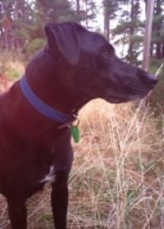

Teoti Jardine is of Maori, Irish and Scottish decent. His tribal affiliations are: Waitaha, Kati Mamoe, Kai Tahu. He attended the Hagley Writers School in 2011 and his poetry has been published in the Christchurch Press, London Grip, Te Karaka, Ora Nui, Catalyst, and JAAM. He had short stories published in the International Issues of Flash Frontier 2013. He is member of the Canterbury Poets Collective Committee. At the moment he and his dog Amie are of no fixed abode
Ian C Smith: A Filigree of Fog Rising

Running a bath qualifies as noisy here
where distant neighbours tend secrets,
a car’s arrival, door closing, trumpeted fanfares.
I rehearse phrases to disdainful cats,
the donkeys a better audience, all ears.
Bold currawongs plunder the cats’ leftovers.

On still mornings I listen to the river
rushing and chattering much like those
who have visited places, or are about to.
Excessive recent snow in the mountains
will make that river babble like Marco Polo,
I joke to the gentle jenny.

On my daily dreamy walk I take care
skirting a sinkhole I named Dragon’s Lair
when my boys were small and I was impressionable.
I fear reaching the edge of consciousness,
familiar canopy of sky darkening,
rephrasing embarrassed unheard cries.

Ian C Smith’s work has appeared in, Australian Poetry Journal, New Contrast, Poetry Salzburg Review, Quarterly Literary Review Singapore, Rabbit Journal, The Weekend Australian,& Westerly. His seventh book is wonder sadness madness joy, Ginninderra (Port Adelaide). He lives in the Gippsland Lakes area of Victoria, Australia.
Jeni Curtis: Ghost horse

I arrive at the field too late
blood gilding my hooves. The ale wives,
the cutpurses, the layers out of bodies
here no longer.

All is silent. Low cloud
weaves, wreathes the trees, scarfs
across the ground, silvered
silk in the moonlight.

An owl cries.

They took his body, punctured
with wounds, pierced with indignities,
broken; crowns whether
gold or thorns come at a cost.

Next year the harvest will
be gathered in as usual and I
will eat fresh hay.

Kings ascend, descend;
world and wheel move on –
poor Richard
for he is gone.

Jeni Curtis is a teacher and writer from Christchurch, New Zealand. She has a keen interest in Victorian literature and history. She is a member of the Christchurch branch of the International Dickens Fellowship, and editor of their magazine, Dickens Down Under. She has published poems, short prose pieces and short stories in various publications including the ChristchurchPress, Takehe, JAAM, the Quick Brown Dog, NZPS anthology 2014, and 4th Floor. She is secretary of the Christchurch Poets’ Collective.



An image of Richard III by Andrew Jamieson
commissioned by the Richard III Society.
Maggie Butt: Do Not Pass Go

A red dot on Free Parking was the clue
that worlds-away in Leeds a girl at Waddington’s
had boxed a huge Get Out of Gaol Free card,
the chance to step back into Baker Street.
The Red Cross parcel’s tins of margarine
and processed cheese were grabbed
to feed their grinding hunger, but Monopoly
was opened gingerly – to feed their fragile hope.

A sentry posted on the hut, the game afoot.
Mayfair-level banknotes for every country
they’d creep through, folded in the pile of top-hat
money. A compass. Silk maps stuffed in the hotels,
imprinted with: the railway routes which chug
across a continent towards the sooty scent
and rush hour roar of Fenchurch Street; the hills
and rivers which split the Stalag from the Strand;
dark forests and wide plains which open
to the Old Kent Road. Do Not Pass Go.

Maggie Butt: In Praise of Beaches

For they fill and empty with human tide
For wives of fishermen have watched upon them
For hollyhocks and valerian may flower upon them
For they have the power to make me lie down and rest
For the incoming tide will not let me oversleep
For they give leave for us to read in public
For the air is thick with the salted words
For they smell of coconut and ice cream
For they add crunch to sandwiches
For the generations may mix freely
For girls shall anoint each other’s backs with oil
For children may shriek without reprimand
For students check into them in lieu of hotel rooms
For sun umbrellas shall blossom in primary-school colours
For the shade of an umbrella is enough
For they have necessitated the invention of the wind-break
For bodies of all shapes are unabashed
For one may compare one’s thighs, both favourably and unfavourably
For they come in flavours of pebble, shingle and sand
For they may be black, white, yellow or red
For they glitter with the powder of seashells
For small clouds shall pretend to be smoke-signals
For sunsets stain them implausible shades of fushcia and gold
For light-houses may wink protectively over them
For they lend themselves to walking and thinking
For plovers will pity the curlews’ lament
For the unwanted and forgotten is washed up on them
For the terminally lonely may leave their clothes in a neat pile

Maggie Butt’s fifth poetry collection, Degrees of Twilight, is due from The London Magazine Editions and follows the illustratedSancti Clandestini – Undercover Saints and Ally Pally Prison Camp. Maggie is an ex journalist and BBC TV producer living in London. http://www.maggiebutt.co.uk
Ian Humphreys: The housewife’s saviour

The slowcooker seemed like the housewife’s saviour.
Pop in some chops, some stock, some bits and bobs
of veg, a wedge of bone for gravy flavour.
The slowcooker steamed – oh housewife’s saviour!
She bought the device as she thought it might save her
lots and lots of time and fuss and washing up.
The slowcooker seemed like the housewife’s saviour.
He moaned about the loans she burnt on Internet buys,
shopping channel lies – but she would not waver.
The slowcooker steamed at his rotten behaviour.
Chuck in a chilli for punch, a pinch of spite,
some pills to still the questions, crush the angst he gave her.
The slowcooker gleamed like the housewife’s saviour.
Slop in some stock, a severed hand with wedding band,
some bits and bobs of bone, his mobile phone, and simmer, simmer, simmer.

Ian Humphreys lives in West Yorkshire and is studying for a Creative Writing MA at the Manchester Writing School. His work has appeared in anthologies and recently in journals including Ambit, Ink Sweat & Tears and Butcher’s Dog. He won the 2013 PENfro Poetry Competition and has been shortlisted for the Bridport and Fish Prizes.
Myra Schneider: ‘It’s Sensitive’

he says, ‘no need to press the buttons hard –
stroke them.’ Sensitive to whom? I wonder
and Shelley’s plant rises before my eyes.

He peers at me through severe lenses as if
suspecting I mistreat it so I don’t say
its sensitivity seems to be an excuse

for shirking work, don’t remark its forbears
willingly washed three towels at a time
but it believes more than two is overload,

donkey-plods and leaves a dripping heap
in its hub. And I don’t complain it roughs up
jumpers, tears silk in its whirring darkness.

Sensitive my foot, I mutter when I climb
into bed that night. In a dream I confront
the gleaming white, implacable body

and, scorning the row of beckoning buttons, raise
an axe in a surge of hate, smash its smugness.
Behind it I see the long-gone machines,

hefty, unsophisticated, trusty
as sheepdogs. But next morning I find it
quite unblemished and white as innocence

belittling the kitchen sink. Sensitive!
The word clangs as I feed it socks and shirts.
Cursing, I stroke its buttons, catch it smirking.

Myra Schneider’s most recent collection is The Door to Colour (Enitharmon 2014). She co-edited Her Wings of Glass, an anthology of ambitious poetry by contemporary women poets (Second Light Publications 2014). Other publications include books about personal writing.

